1. **Write an essay: Importance of Data Cleaning in Data Science**

**The importance of data cleaning in data science**

**Data is the lifeblood of modern data science and analytics. However, raw data collected from various sources is often messy, inconsistent, incomplete, and inaccurate. This "dirty" data, if not addressed, can lead to unreliable insights, flawed predictions, and ultimately, poor decision-making. This is where data cleaning, also known as data cleansing or data scrubbing, steps in as a crucial and foundational component of the data science workflow.**

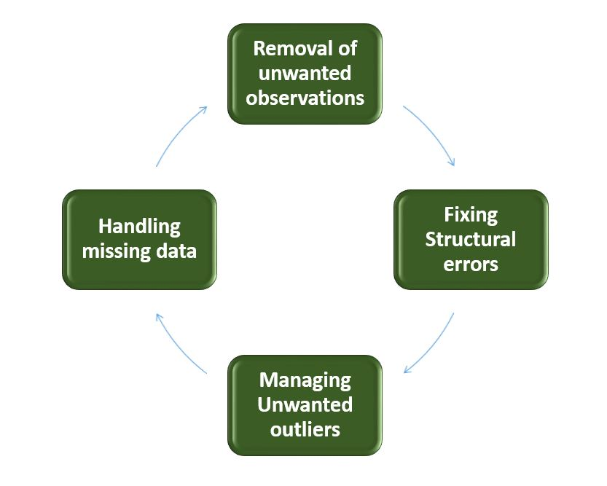

**Data cleaning involves a systematic process of identifying, correcting, or removing errors, inconsistencies, and inaccuracies within a dataset to improve its overall quality and usability. This process ensures that the data is accurate, complete, consistent, and relevant for analysis, machine learning model training, and informed decision-making.**

**Key aspects and benefits of data cleaning**

1. **Ensuring Accuracy and Reliability: Raw data frequently contains errors such as typos, incorrect values, and duplicate entries, which can significantly distort analyses and lead to erroneous conclusions. Data cleaning addresses these issues, ensuring that the data accurately represents the real-world phenomena it is intended to capture and making it a trustworthy foundation for any subsequent analysis.**
2. **Facilitating Effective Analysis: Clean data allows for smoother and more effective data analysis. When data is consistent in format, units, and structure, it simplifies the process of querying, filtering, and aggregating the information, allowing data scientists to focus on uncovering insights rather than grappling with data quality issues. This efficiency can significantly reduce the time and effort required for the analysis phase of a project.**
3. **Enhancing Model Performance: Machine learning models are highly sensitive to the quality of the data they are trained on. Dirty data can lead to biased models that produce inaccurate or unreliable predictions. Data cleaning, through tasks like outlier removal, handling missing values, and correcting errors, ensures that the models learn from high-quality data, leading to improved accuracy, robustness, and generalizability to new data.**
4. **Enabling Better Decision-Making: Ultimately, the goal of data science is to derive actionable insights that drive better decision-making. By providing accurate, consistent, and reliable data, data cleaning empowers businesses to make well-informed strategic and operational decisions, leading to improved outcomes and competitive advantage.**
5. **Boosting Efficiency and Productivity: Investing time in data cleaning upfront can save valuable time and resources in the long run. When data is clean, data scientists and analysts spend less time fixing errors, troubleshooting issues, and reconciling inconsistencies, allowing them to dedicate more time to analysis, interpretation, and generating valuable insights.**
6. **Ensuring Data Governance and Compliance: Data cleaning is an integral part of effective data governance and regulatory compliance. By ensuring data accuracy, consistency, and adherence to specific standards, data cleaning helps organizations meet data protection regulations, reducing the risk of penalties and maintaining a positive reputation.**

**Common data cleaning tasks**

**The data cleaning process often involves several key tasks, including:**

* **Removing Duplicates: Identifying and eliminating redundant records to ensure data uniqueness.**
* **Handling Missing Values: Addressing missing data points through techniques such as imputation (replacing with estimates) or deletion, depending on the context and extent of missingness.**
* **Correcting Inaccuracies and Errors: Fixing typos, incorrect values, and other data entry errors.**
* **Standardizing Formats: Ensuring consistency in data formats, units of measure, and naming conventions across the dataset.**
* **Addressing Outliers: Identifying and deciding how to handle extreme values that might distort analysis or model performance.**

**Conclusion**

**Data cleaning is not merely a preparatory step in data science; it is a critical and continuous process that underpins the validity and impact of all subsequent analytical endeavors. By ensuring the accuracy, consistency, completeness, and reliability of the data, data cleaning empowers data scientists to extract meaningful insights, build robust models, and make confident, data-driven decisions that propel businesses forward. As the volume and complexity of data continue to grow, the importance of embracing effective data cleaning practices will only become more paramount for any organization striving to unlock the full potential of its data assets.**